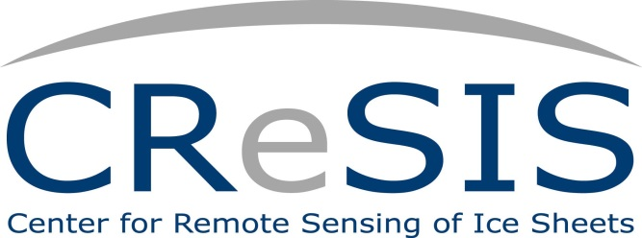

Date: June 17, 2013

Agenda
9:00 am

CReSIS Middle School Summer Program Opening

Welcome Dr. Darnell Johnson,
CReSIS Education Coordinator

Purpose Dr. Linda Hayden,
Principal Investigator
Director, CReSIS Education Program

Summer Schedule & Program Dr. Darnell Johnson,
CReSIS Education Coordinator

Introductions Summer Researchers & Staff

12:00 noon

Lunch/Seminar Jerome Williams, PhD Candidate,
Indiana University

1:00 pm – 3:00 pm

Digital Camera Training Jeff Wood, ONR Webmaster

STAFF
Principal Investigator: Dr. Linda Hayden, Principal Investigator
Program Coordinator: Dr. Darnell Johnson, Education Coordinator
Middle School Coordinator: Mrs. Wanda Hathaway, PCPS
Digital Camera & Power Point Trainer: Mr. Jeff Wood, CERSER Webmaster
GIS/GPS Trainer: Mr. Je’aime Powell, CERSER Lab Manager
Climate Change Trainer: Mrs. Cheri Hamilton, Outreach Coordinator
Hydrology Trainer: Mrs. Wanda Hathaway
Robotics Facilitators: URE Math Team
Student Assistants URE Math Team
Administrative Assistants: Mr. Joal Hathaway, Mrs. Marisol Denny,
& Mr. Kevin Jones

